

American International University-Bangladesh (AIUB)  
**Department of Computer Science  
Faculty of Science &Technology (FST)  
Fall 2019-2020  
CSC 2210 Object Oriented Analysis and Design (OOAD)**

**Section: P  
Group No: 04**

**School Management System**

An Object-Oriented Analysis and Design (OOAD) project submitted

By

*Mulk, MD. Abdul Al Malikal (18-37803-2)*

*Siddique, Al Amin (18-37870-2)*

*Saha, Ankur (18-37913-2)*

*Hossain, MD. Mridul (18-38670-3)*

The project will be Evaluated for the following Course Outcomes

|  |  |
| --- | --- |
| **CO3:** Formulate a baseline document to perform feasibility study of a proposed project idea | Total Marks |
|  |
| Project Background Analysis [5Marks] |  |
| Project Content Knowledge [5Marks] |  |
| Project Feasibility Study [5Marks] |  |
|  | |
| **CO4:** Design a Complex engineering problem using UML Tools and explain the system using a project report and presentation | Total Marks |
|  |
| Diagram Standard [5Marks] |  |
| Report Organization [5Marks] |  |
| Presentation Delivery [5Marks] |  |

1. **PROBLEM DOMAIN**
   1. **Project Background Analysis**

In a school, officer has to deal with a lots of information like student’s admission documents, employee appointing and personal information, course related information and many other information of the school. So, it is kind of difficult to keep track of all these information including searching, updating, deleting and adding. Again it is also difficult to keeping track on each employee’s curriculum in the school.

The root reason of this problems are lack of employee in the management section or, time consumption. The information is huge but working people is small. This small bunch of people cannot handle all this information in a short time so the school management cannot works in fluent way. It will be hard to take any frequent decision if an issue occur.

* 1. **Project Solution and Feasibility Analysis**

The solution of this problems it to use a management system. Through using this management system officers can keep track with the information of all aspect of the school as all the information will be stored in a database and the system has access to the database. So that an immediate step can be taken if an issue occur.

In the software there is employee and teacher section, admission section, salary and workhour management section and also course section. In all this sections contains information about their individual characters. So that the management officer can track the employees as well as the students. So the discipline of the school will be maintained.

The existing software solutions are available to solve the aforementioned problem are quite same as ours. Through their system it is also possible to keep tracking the employees and the students.

The teacher suggestion section makes our project distinct from other similar projects and yes this project duplicates functionality already available in the market.

1. **UML DIAGRAM**
   1. **Use Case Diagram**

**Diagram: 01(Student admission)**

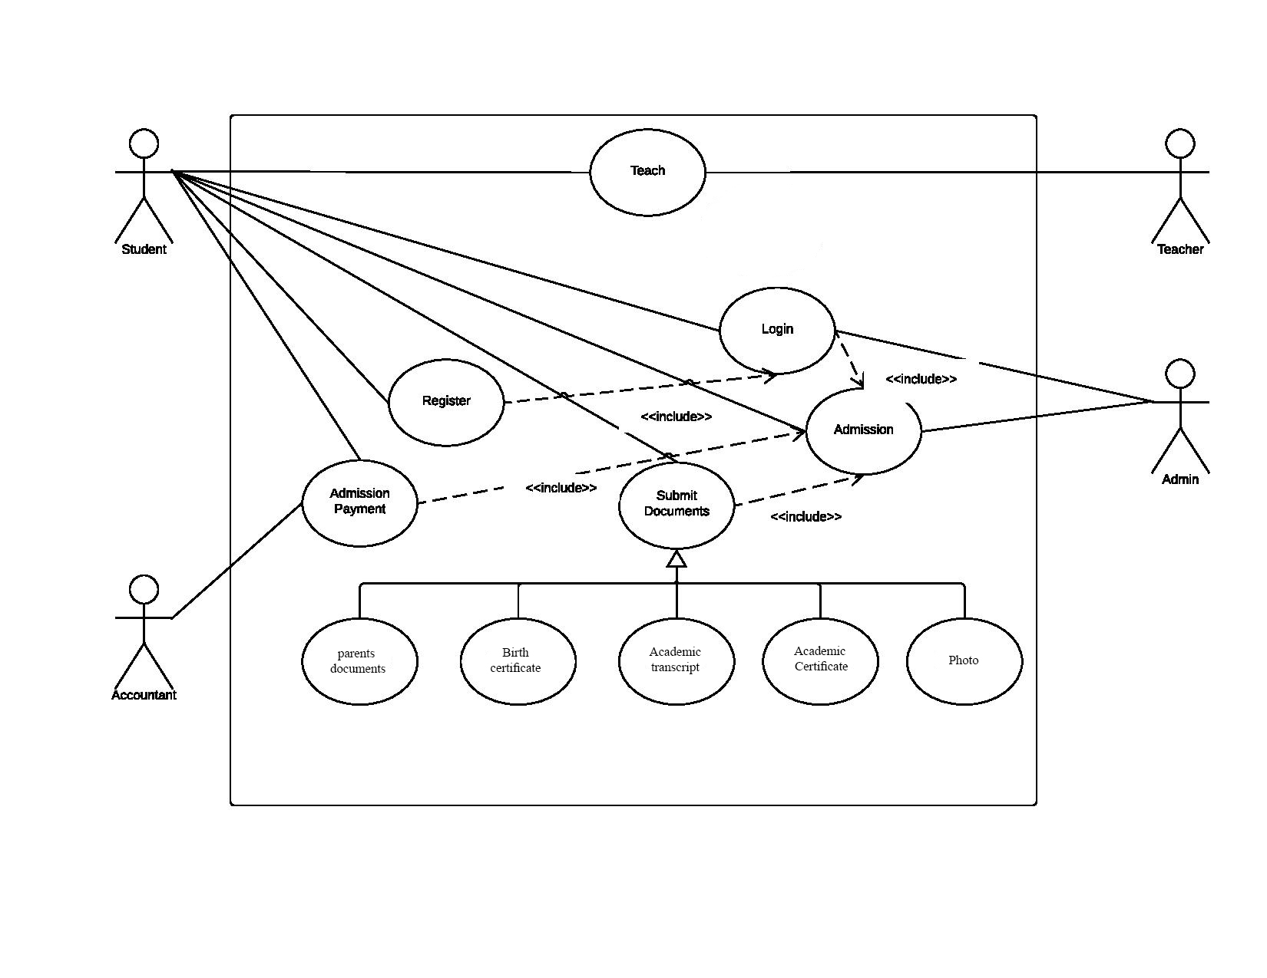

**Diagram: 02**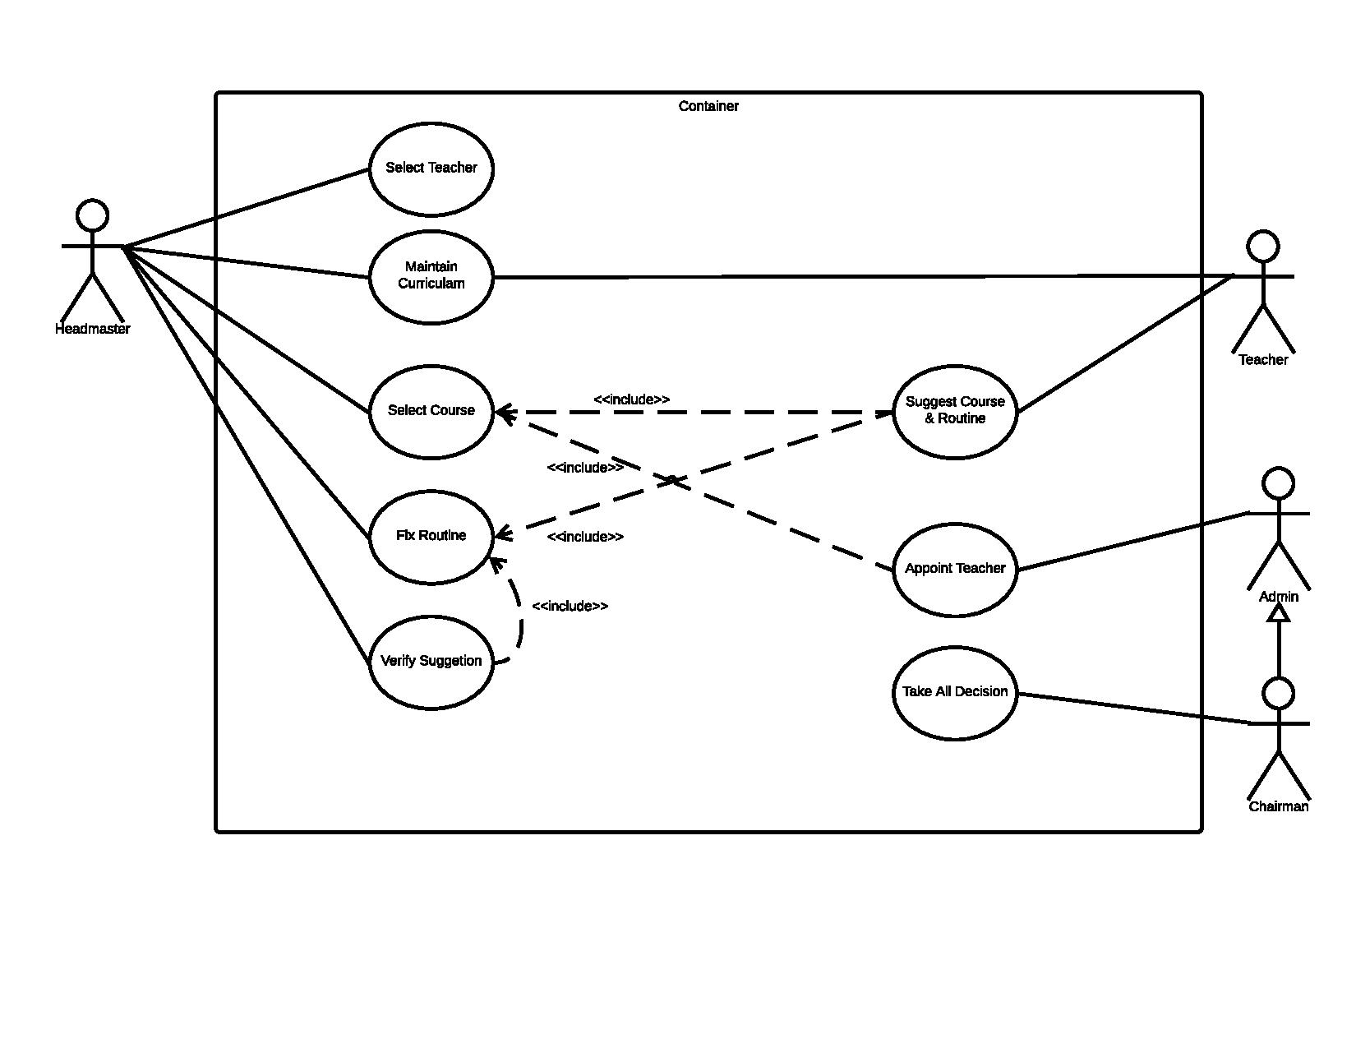

**Diagram: 03(Employee appointing)**

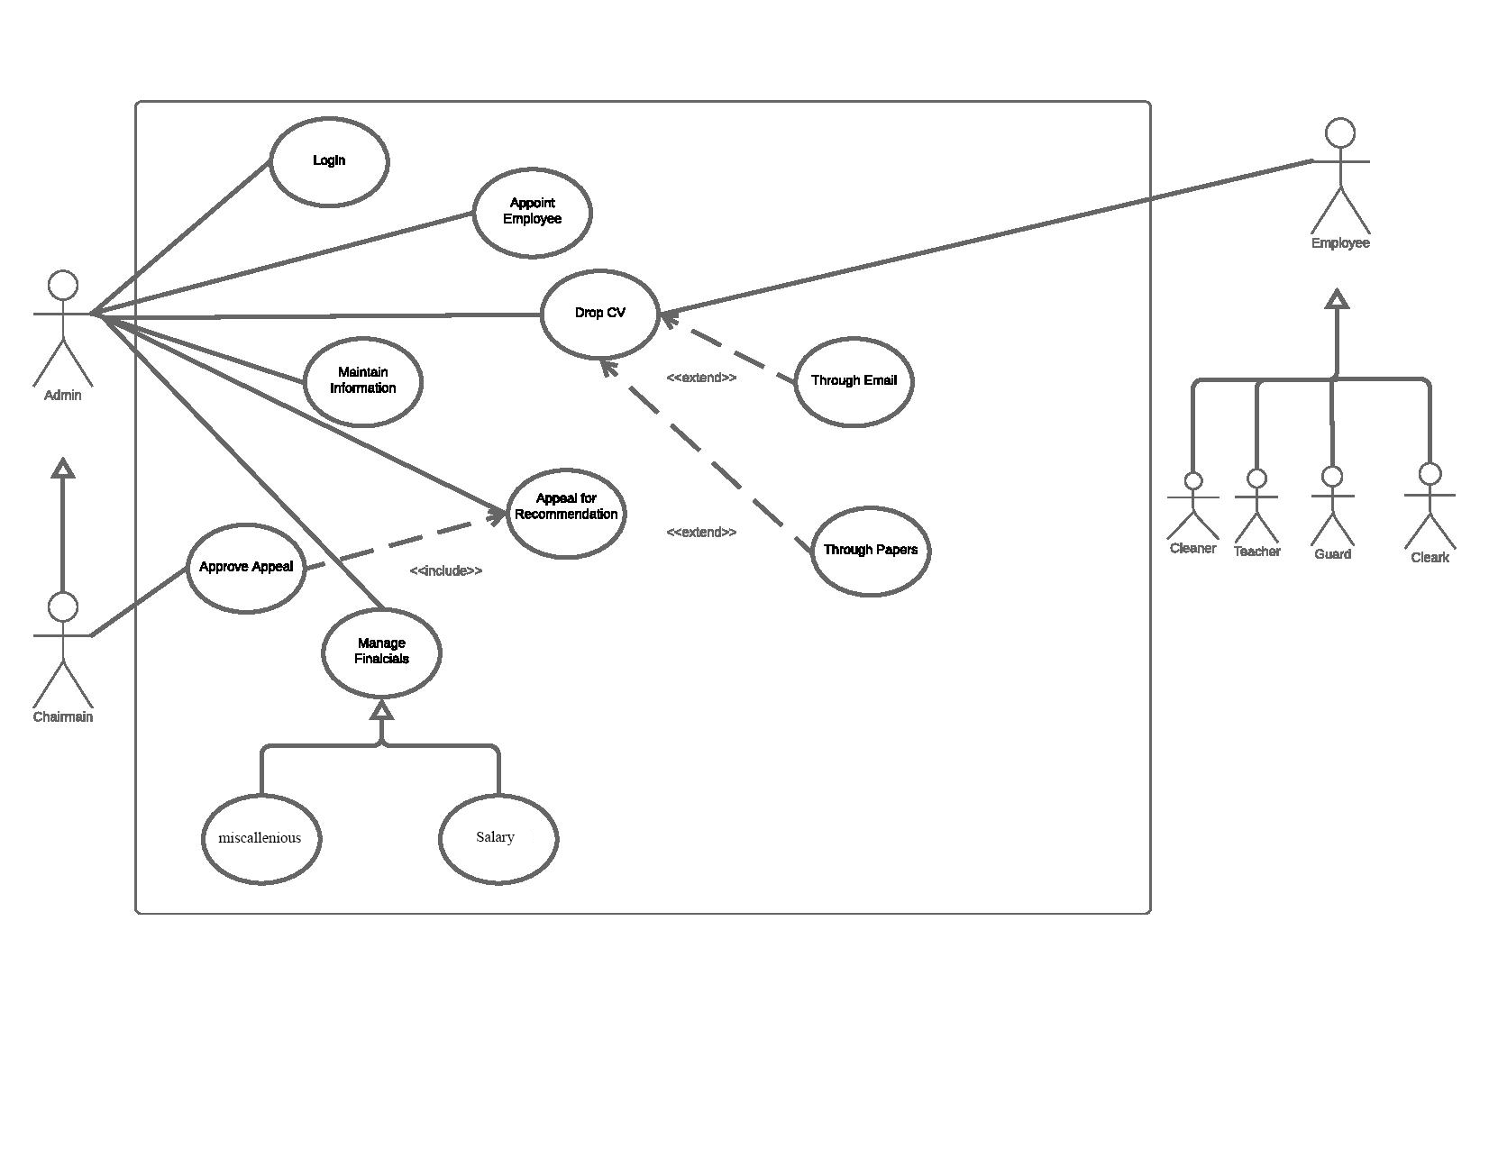

* 1. **Class Diagram**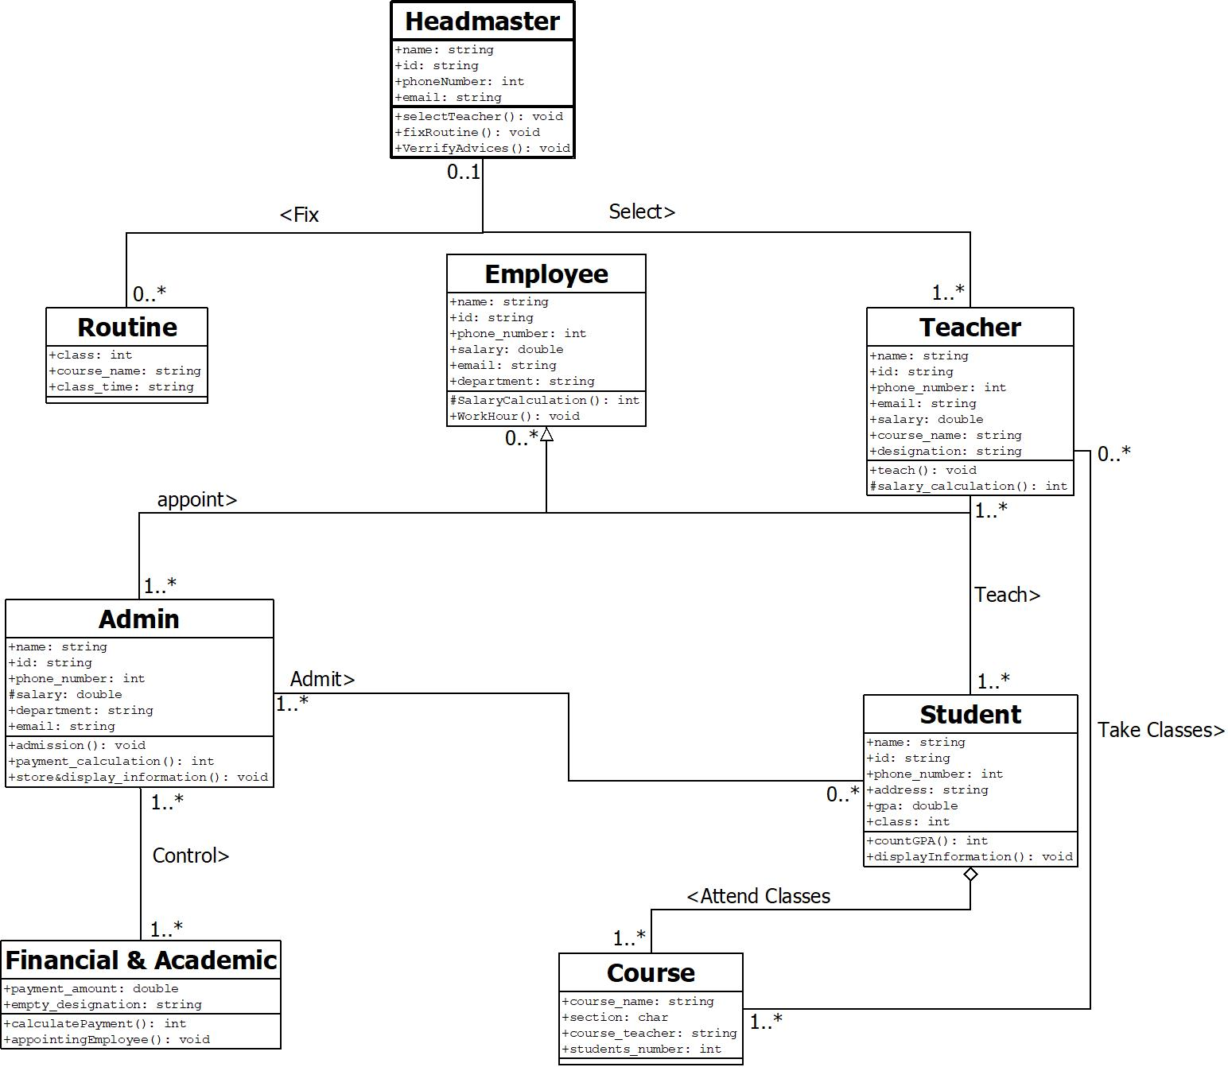
  2. **Activity Diagram**

**Diagram: 01(Employee appointment)**

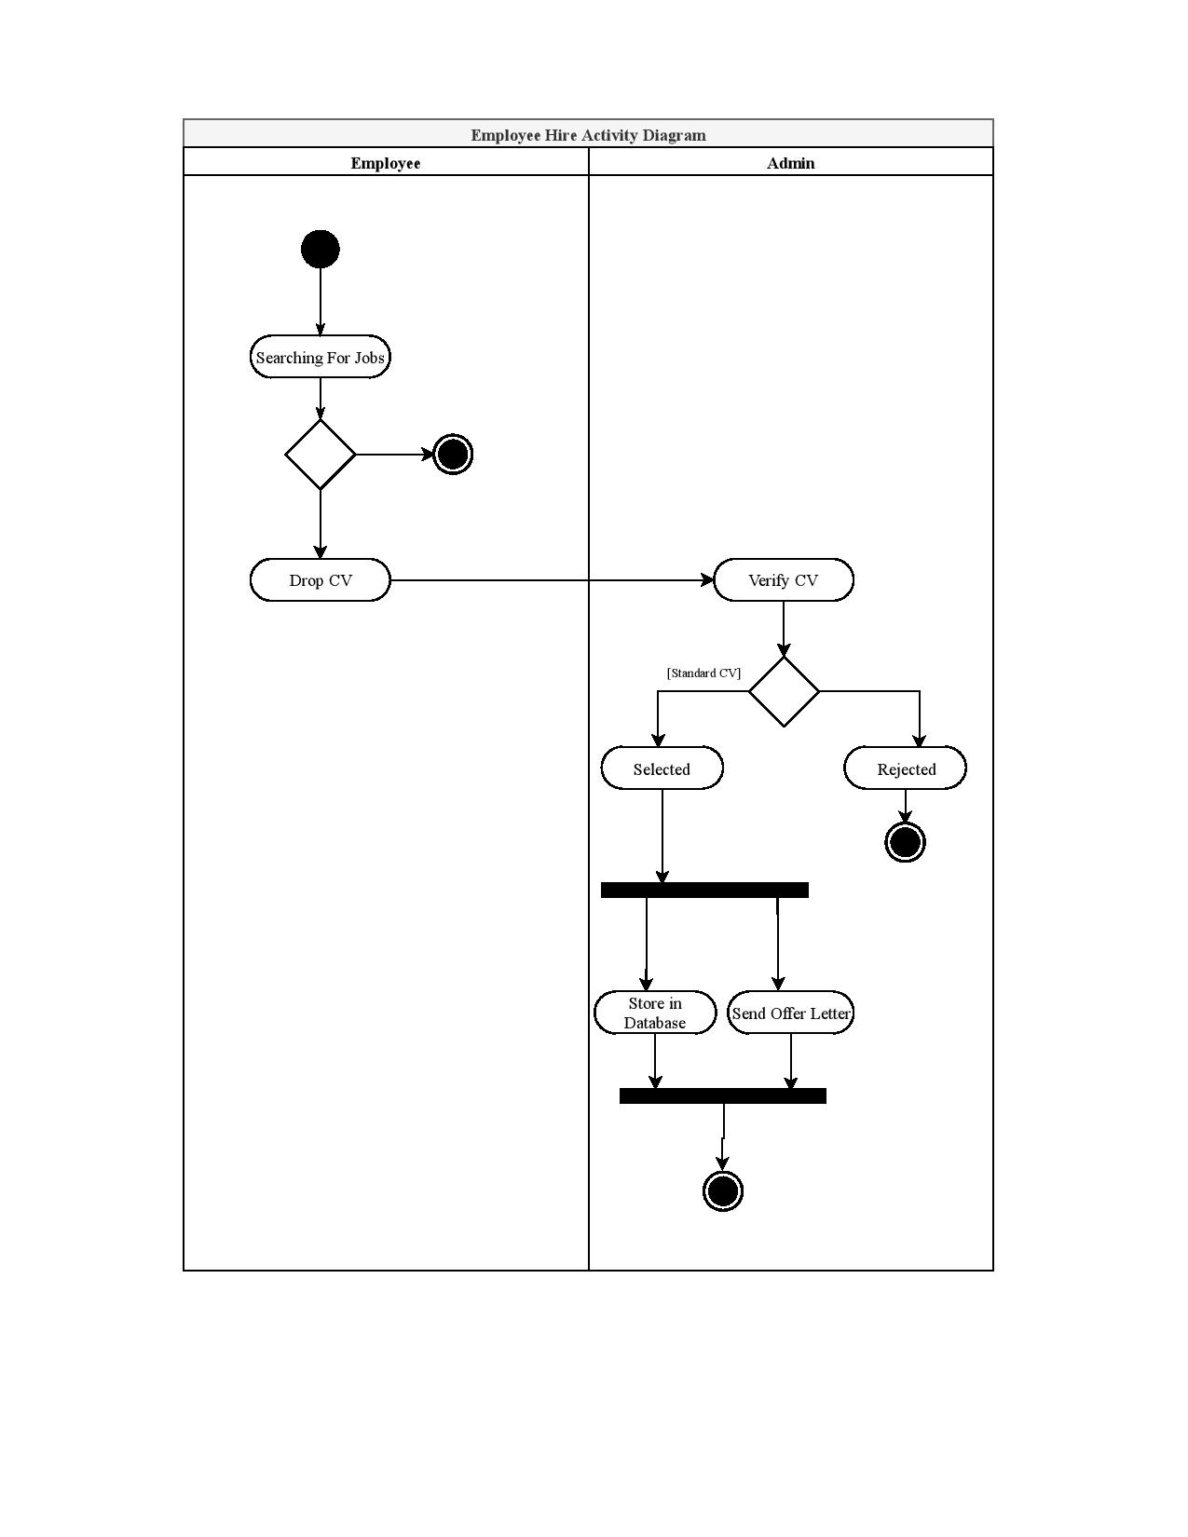

**Diagram: 02(Student Admission)**

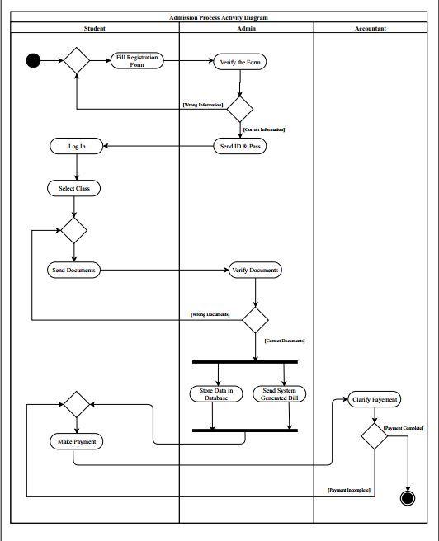

**Diagram: 03(Teacher Appointment)**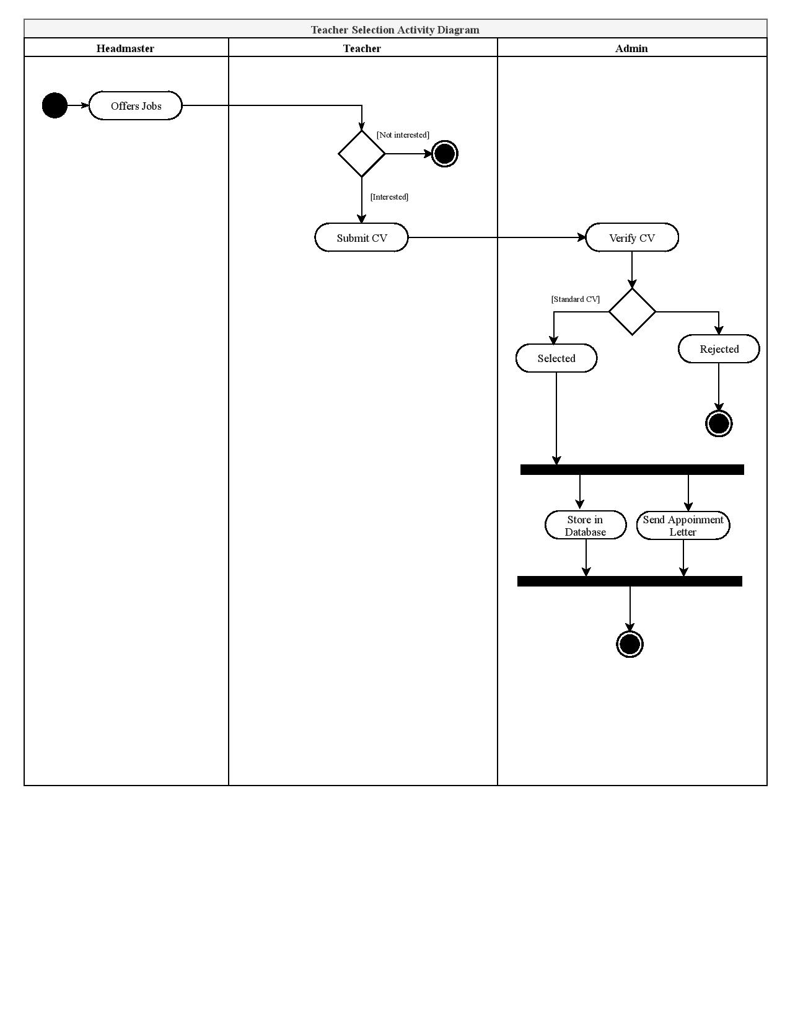

* 1. **Sequence Diagram: 01(Appointing Teacher)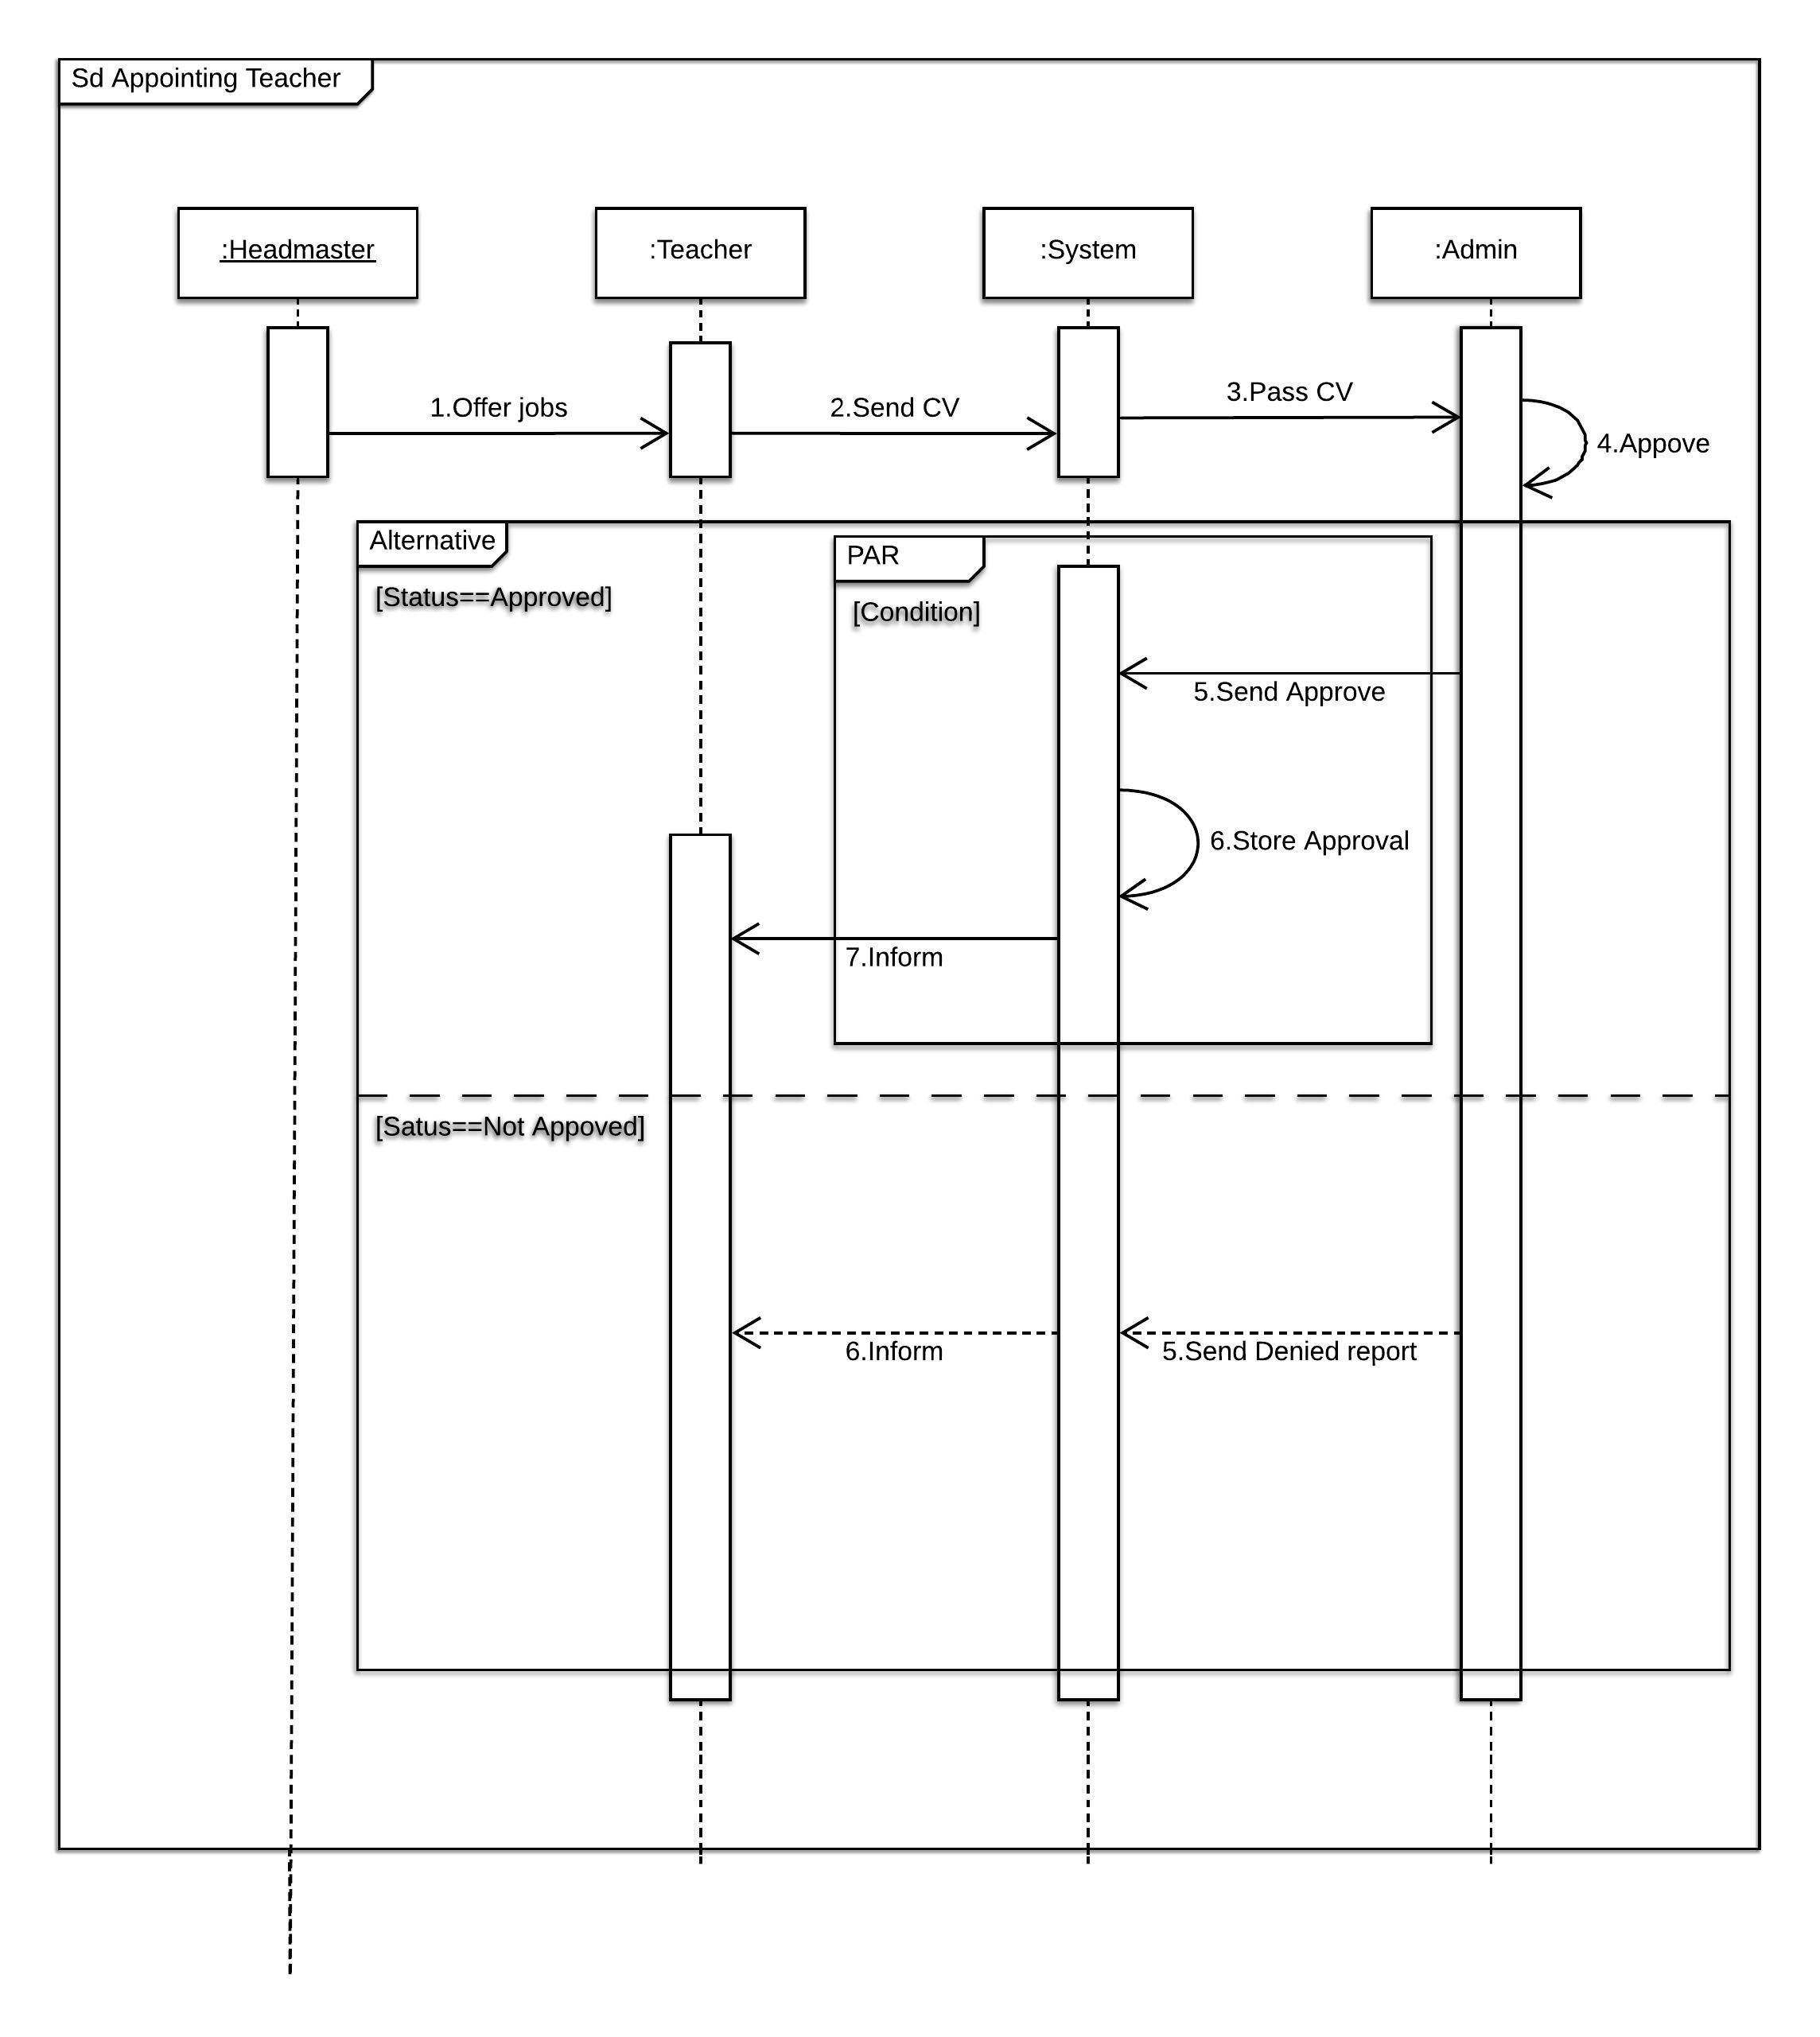 Diagram: 03(Appointing Employee)**

